CURY PARISH COUNCIL

I hereby summon you to attend a Meeting of Cury Parish Council to be held on Thursday 28 September 2023 at 7.00pm in the Gunwalloe Village Hall, Gunwalloe. The public and press are cordially invited to attend.

1. Apologies for Absence
2. Declarations of Interest – Members to declare personal and prejudicial interests (including details thereof) in respect of any item(s) on this Agenda
3. Chairman’s Comments
- To agree the Minutes of the Parish Council Meeting held on Thursday 27 July 2023
5. Matters arising from the above approved minutes which are not covered in this agenda
6. Reports
(a) To receive an update on Cury School
(b) To receive the Report from Cornwall Councillor
(c) Helston and South Kerrier Community Area Partnership
7. Planning
(a) To consider and respond to any Planning Applications received
(i) PA23/06737 – Colvennor Farm – General purpose agricultural shed
(ii) PA23/05929 – Cury School – Disused school to be refurbished as a SEN school with small extension to rear, roof replacement and new car park
(b) To receive any Planning Decisions
(i) PA23/03286 - The Wheel Inn, Cury Cross Lanes - Remodelling and reinstatement of public house (with replacement managers accommodation at first floor with new letting rooms) with new extensions over the footprint of storage barn and new storage area. Demolition of existing storage building, toilet and family room. Construction of new freestanding annexe in car park providing four additional holiday letting apartments – Approved
(ii) PA23/02208 - Sunny Corner, White Cross - Loft conversion and balcony area - Approved
(c) Any correspondence received
8. Parish Matters
To consider the following:-
(a) Playing Field inc. Litter Picking
(b) Highways
(c) Public Rights of Way
(d) Public Open Spaces (Cemetery, village green, etc)
(e) Emergency Plan
9. To discuss the purchase and erection of a ‘Parish Council Meeting this Thursday’ sign
10. Financial Matters
(a) To receive and approve the financial report for the previous two months
(b) To receive any LGA 1972 Section 137 Requests for grant funding
(c) Other matters
11. Correspondence
12. Matters for the next Parish Council Meeting
To receive notice of items to be included on the agenda for the next Parish Council Meeting scheduled to be held on Thursday 23 November 2023 in the Cury Village Hall

Council to withdraw if necessary under the Public Bodies Admissions to Meetings Act 1960 Section 1, Local Government Act 1972 Section 100 Sections 2 & 3 and Local Government Act 172 Schedule 12 Section 42. Given under my hand this Twenty first day of September 2023.

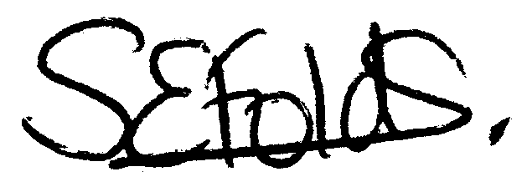

Samantha Folds
Clerk to Cury Parish Council

